- setx JAVA_HOME "C:\Program Files\Java\jdk-21"
  - It is used to set the environment variable permanently.
- How the Java code works?
  - Java Code (.java) ------<compiler (javac)>------ Byte Code (.class)
  - Byte Code goes into JVM (JVM accepts only byte code)
  - JVM only run only one file.
    - It says, even if you have 1000 files, you need to tell me which is the first file that I’ll run.
    - That file needs to have main method.
  - Whenever you run a .java file, one .class file will get created. It is the Byte Code file.
- To run a java code (file name is let: Hello.java)
  - If you run this using javac Hello.java, one file will be created depending upon the classname used inside the Hello.java.
  - 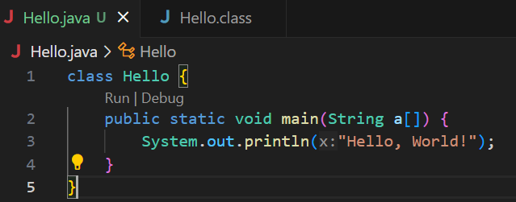
  - Here I gave the classname same as the filename.
  - But, it doesn’t matter what is the filename; you can give the classname different.
  - But, the .class file will be created with the classname that is mentioned inside the .java file.
  - 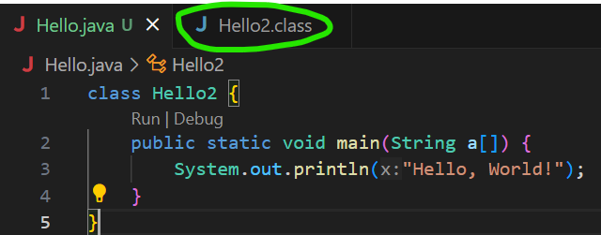
    - You can see here, I gave the class name Hello2, and the file got created is Hello2.class.
    - But, if you are creating public class, then the filename must be same as the classname.
  - First you need to run the command javac Hello.java
    - It’ll create the .class file.
  - Then, run the .class file using java Hello
    - Here, don’t write java Hello.class
- JVM(Java Virtual Machine) is present inside JRE(Java Runtime Environment).
  - When you need to run something, it might requires some libraries.
  - JRE provides that.
  - JVM is just a part of JRE.
  - Kitchen Analogy:
    - The kitchen provides the environment to cook a dish.
    - Utensils and Ingredients are like the libraries and resources JRE provides.
- JVM < JRE < JDK (inner to outer layer)
  - JVM present inside JRE and JRE present inside JDK.
  - JDK is used by developers to develop the code and all.
  - If you want to run your application in any other system, that doesn’t require JDK. Only JRE should be there to run the application.
  - 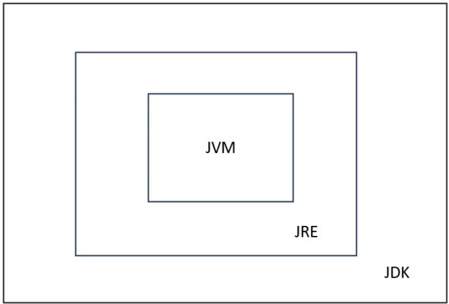
- Is JVM like a virtual machine on top of OS?
  - Yes and No:
  - ✅ Yes: It behaves like a virtual computer for Java bytecode. That’s why Java is “Write Once, Run Anywhere.”
  - ❌ No: It doesn’t emulate hardware or run another OS. It sits on top of the real OS, using system calls, memory, CPU instructions, etc.
  - So, JVM is an abstraction layer, not a full-blown VM like VirtualBox.
- Variables
  - Primitive
    - Integer (byte(1), short(2), int(4), long(8)) (for long: you need to write l as suffix)
    - Float (double(8), float(4)) (2.3 => double, 2.3f => float) (default is double)
    - Character (2 bytes)
    - Boolean (doesn’t work like 0 and 1; only true and false works)
    - 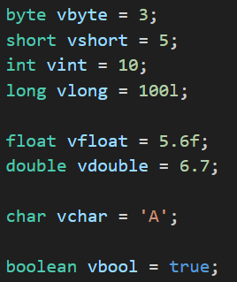
    - NOTE: you can’t double quotes in char variables. That is only for string.
    - 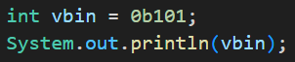
      - You can also write in binary format, when you execute this, output will be 5.
      - As 101 = 5
      - For hexadecimal, use 0x as prefix.
    - Unlike C++, in Java also if you print (int)(ch) where ch is char variable, it’ll print the ASCII value of that character.
    - Higher sized variables can’t be assigned to smaller sized variables; but vice-versa is possible.
      - Ex: int can’t be assigned to short; but short can be assigned to int.
      - If you are assigning larger to smaller, then you need to do type casting.
        - 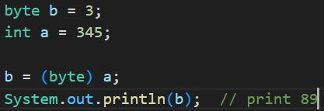 (345 % 256 = 89)
    - Type promotion:
      - lets say you have 2 byte variables 10, 30.
  - When you multiply these and store the result in a variable, it’ll automatically become int (as 300 is not in the scope of byte variable).
- Some points to be remembered
  - Just like C++, here also, when you divide 2 inegers, it’ll return a integer value only. Not float number.
  - Operators (arithmetic, logical, ternary and all), Conditional statement (if, else if, else) are same as C++.
  - switch case statement is also same as C++.
  - string + int + int => for example: “abcdef “ + 5 + 6 => “abcdef 56”
    - It’ll concatenate.
  - 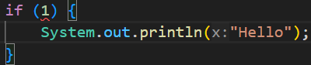
    - This is wrong. It’ll give error that can’t convert int into boolean.
- Classes and Objects
    - 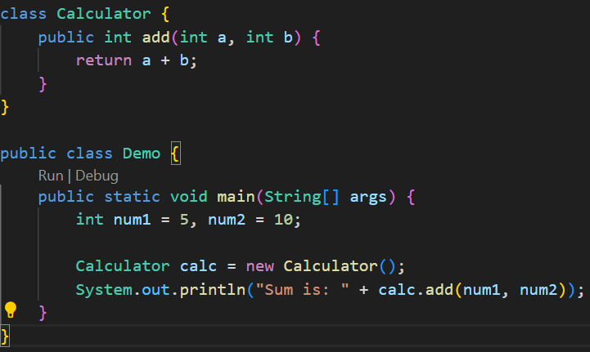
      - You can’t run this directly using java filename.java, you need to compile and run separately.
      - Bcs, when you compile it, 2 .class files will be created i.e. Calculator.class and Demo.class.
- JDK JRE JVM
  - JDK: Java Development Kit
  - JVM: Java Virtual Machine
  - JRE: Java Runtime Environment
  - Compilation happens in JDK, Running happens in JVM.
  - Most of the time, you’ll be using some built-in libraries; in this case JRE comes into play.
    - One extra layer outside JVM, which is JRE, stays there to provide the libraries during the run.
- Methods
  - While creating a method, you should provide a proper access modifier.
  - 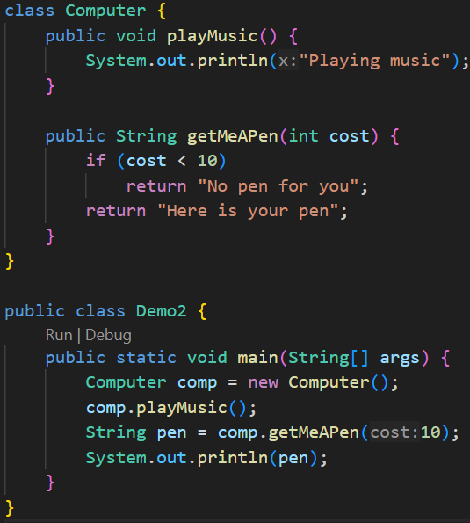
  - Method Overloading
    - 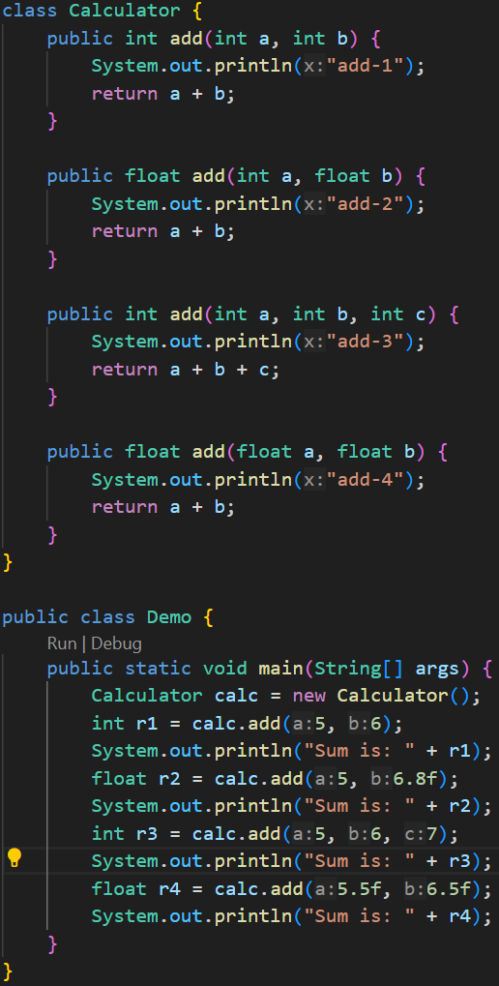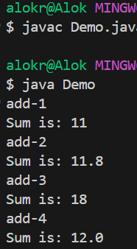
      - Number of arguments, type of arguments, type of return type: depending upon these, method overloading can be done.
- Stack and Heap
  - Inside JVM, there are 2 types of memory.
    - Stack (Last-In-First-Out)
    - Heap (open space)
  - 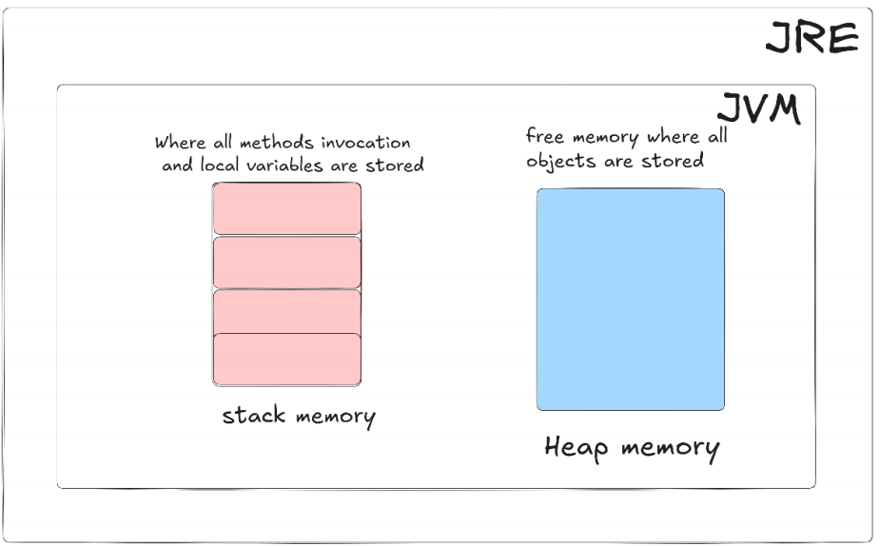
  - 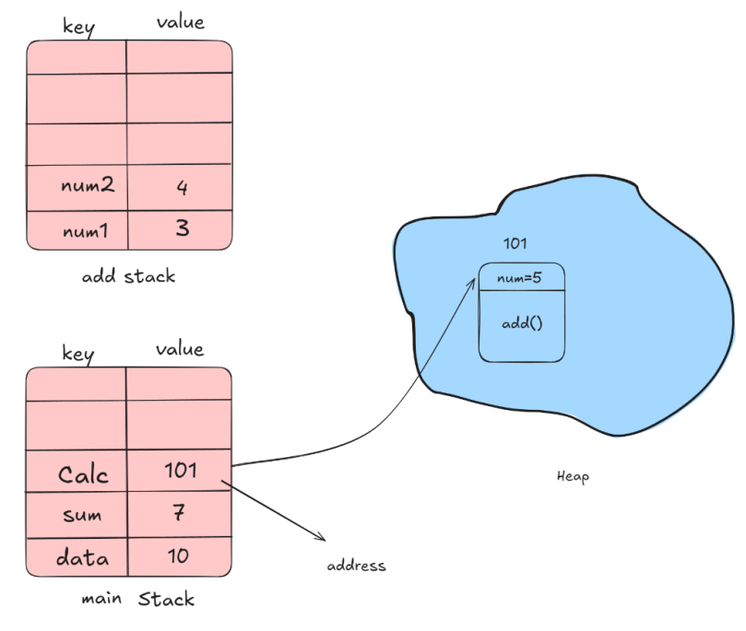
    - Each method takes its own stack like main method, add method (consider previous example)
    - The stack is having 2 partitions: left side is for key and right side is for value.
    - Whenever you create an object out of a class, it is created inside the Heap.
      - In the heap, inside the memory block that the object acquires, is having 2 parts.
        - One is for properties (instance variables)
        - One is for method definitions
    - When you call the method using the object, the method gets loaded inside the Stack, create its own local variables and gets executed.
    - Note: the instance variables inside a class will be staying inside the heap only.
    - 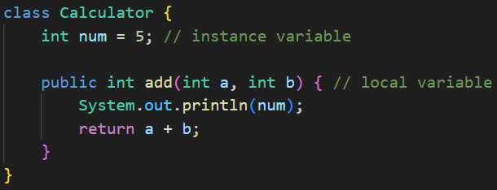
    - Instance variables are specific to objects, not class. Means, each objects will have independent instance variables.
      - Because, each objects will be having different memory blocks inside the heap.
    - The reference of the object inside heap, is stored inside the stack.
- In Java, everything, which is an object, gets created inside Heap.
  - Ex: Array,
- Array
  - int arr[] and int[] arr
    - These both are exactly same
    - But, int[] arr is preferable; as it shows arr is of int[] type.
    - First one i.e. int arr[] is derived from C/C++ style; which is 100% correct in Java.
  - 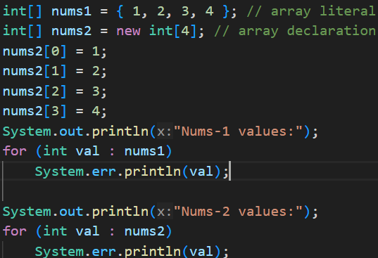
    - These are 2 types of Array declaration.
    - Both are fixed sized only.
    - An non-initialized array’s values will be 0.
  - 2D Array:
    - 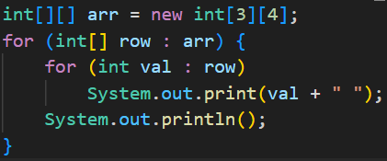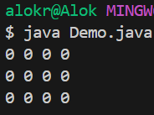
    - Arrays are not having dynamic sized (for dynamic size, ArrayList is used)
    - But in case of 2D array, we can create an Array having different sized rows.
    - 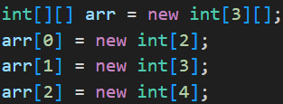
      - Just don’t mention the column size while creating a 2D array and after that initialize the rows.
      - It is called jagged array.
      - 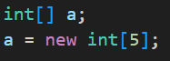
        - It’s just like this.
      - We are creating an array of sized 3 (new int[3][]) where each value is of type int[]. After that we are initializing those.
  - Array of Objects:
    - 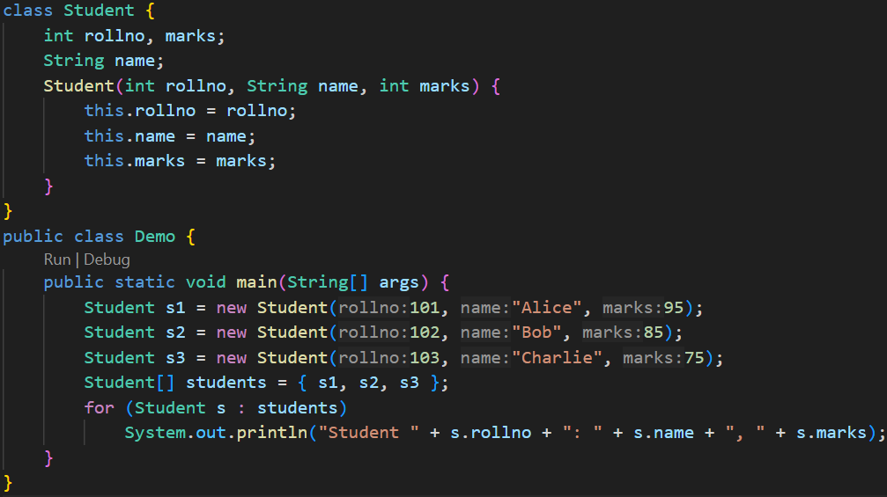
    - 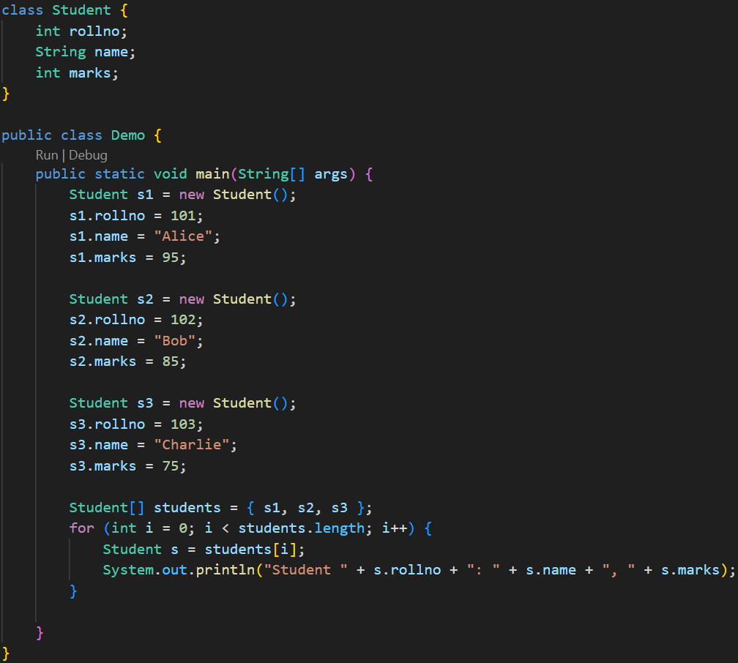
  - Drawbacks of Array:
    - You can’t change the size of the array.
    - O(n) for searching.
- Strings
  - 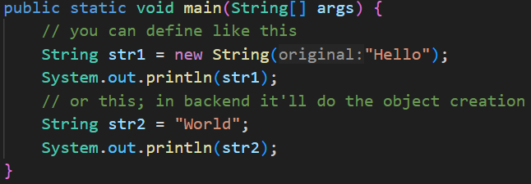
  - When you create a string variable, one object of type String will be created in heap and your variable will store the reference of that object.
  - One part is there inside Heap called as String Constant Pool,
    - Whenever you assign one string value to a variable, one constant string literal will get created inside that String Constant Pool and reference of that will be stored in a variable.
  - Immutable Strings:
    - Lets you create String variables having same value, then both the variable will be storing the reference of same string literal as in side the String Constant Pool, all the strings stored are unique.
    - 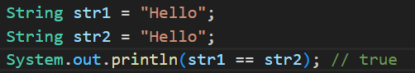
    - Whenever you assign one string literal to a variable, it first checks inside the String Constant Pool (SCP);
      - if that particular literal is not present then it creates one and store its reference inside the variable.
      - If present, if just store the reference of existing string literal in the variable.
      - For concatenation: there are the following cases:
      - 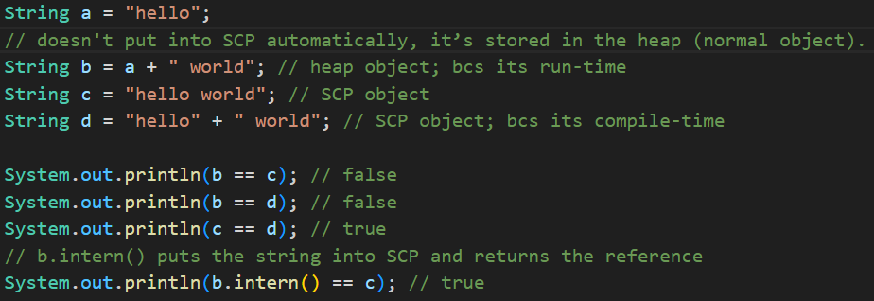
  - Mutable Strings:
    - StringBuffer is used to create mutable strings.
    - 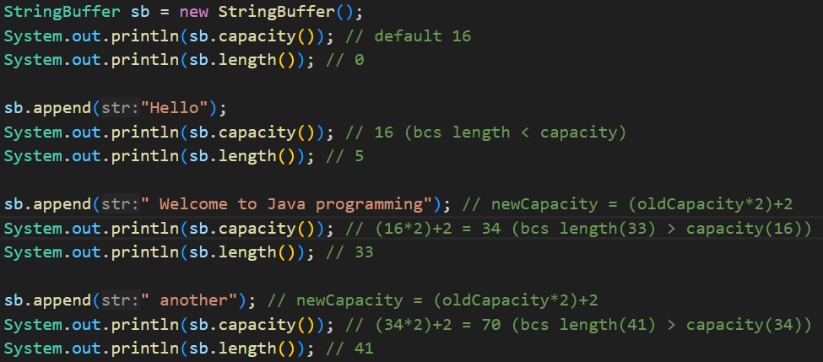
      - By default, the capacity is 16+string length.
      - If the string size exceeds the capacity, then the capacity will be increased with the formula: New Capacity = (Old Capacity) * 2 + 2
- NOTE Inside a non-static method, use of this keyword to access the instance variables is optional. (this is required in case of naming conflict; constructor is example here)
  - 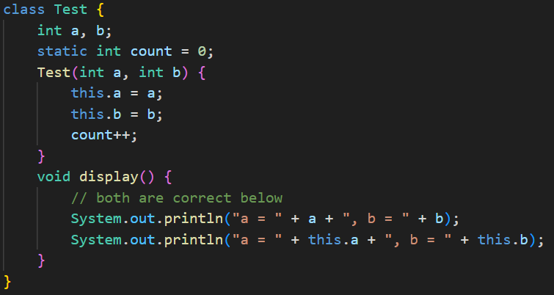
- static keyword:
  - Static variables is shared among all the objects.
  - Static variables are stored in the Method Area (a part of JVM memory), not on the Heap.
  - You can call access/modify the static variables using objects as well; but it is not preferable.
  - You should access the static variables using class only
    - ClassName.StaticVariableName
  - 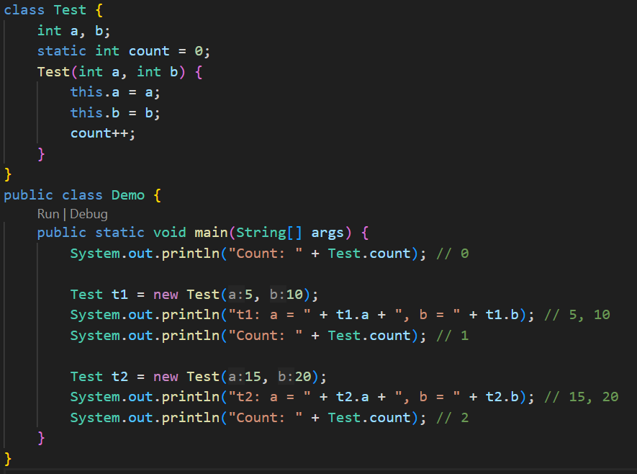
    - Example of Static Variable.
  - From a static method, you can’t access the instance variables. Because instance variables are specific to the objects but static method is specific to class; not objects.
    - If you want to access the instance variables, then you can pass the object as an argument to the static method.
    - 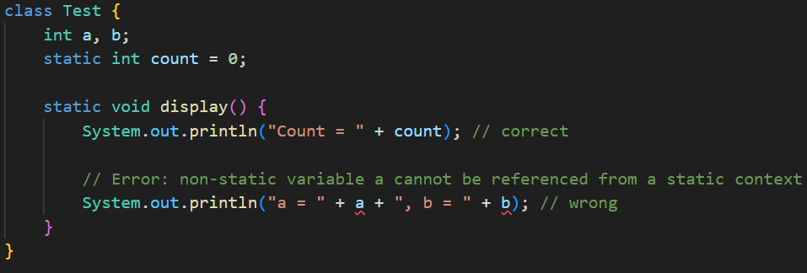
    - 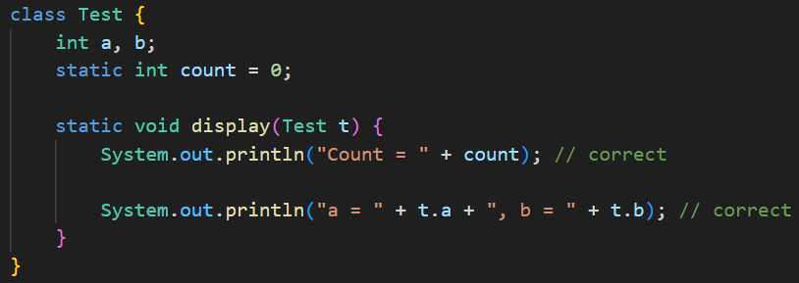
      - Now it is correct.
    - If you create any variable inside a static method, then after the method is executed then the variable will be gone.
- Static Block
  - Whenever you instantiate a object with a class, then first the class gets loaded then the object will be created.
    - If you are instantiating more than one object with a single class, then loading of class will happen only once.
      - When the first object will be created, class will be loaded;
      - after that when 2nd object will be created, it sees the class is already loaded; so now only object creation will happen.
    - There is a static block, where you can assign values to the static variables. This block gets called when the class is loaded.
    - It means, even if you are creating n number of objects (or) you call any static method of that class n times, static block will be executed only once.
      - If there is no object getting created (or) not any static method call, then static block will not be executed.
    - 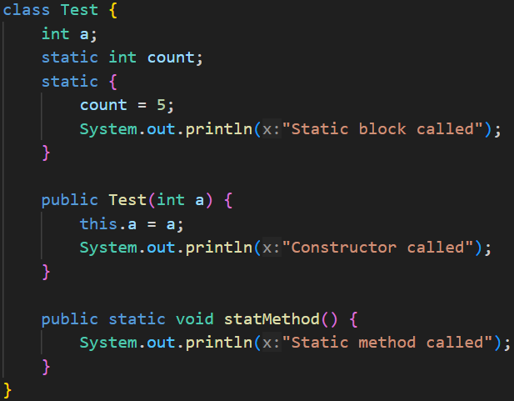
      - This is the class having static block.
    - 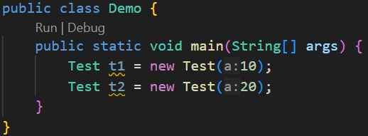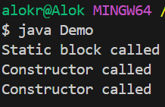
      - Because, class was loaded only once.
    - 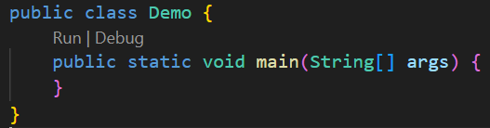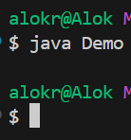
      - Because, as no object was created; so class loading didn’t happen.
    - 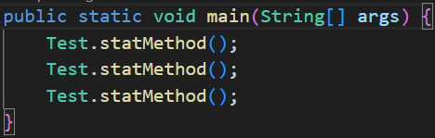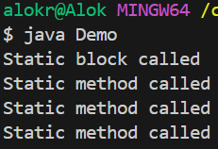
      - Because, only during the first static method call, class was loaded.
    - 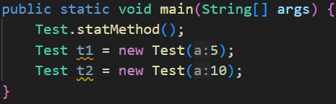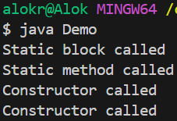
      - When static method got called, class was loaded; so while instantiating objects, it didn’t require to load the class.
    - If you want to load the class even if no static method got called or no object got instantiated; then you can use Class.forName
      - It load the class to the memory using class loader.
- Encapsulation: (hiding variables)
  - 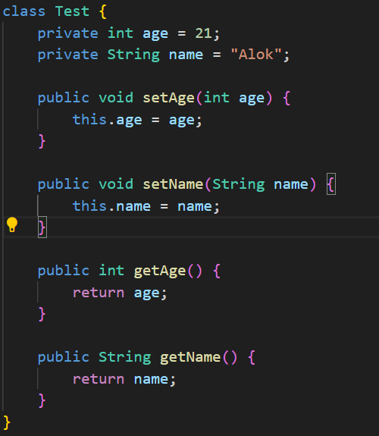
    - You can set the access parameters of the variables and add getter and setter methods for those.
- If you don’t specify any access modifier, then by default it’ll be package-private. (neither private nor public not protected) (its valid for class, method, variables inside class).
- Constructor
  - 2 types of constructors are there:
    - Default constructor
    - Paremeterized constructor
  - You can define more than one constructors;
  - constructor name will be same as the name of class; it’ll not have any return type.
  - All the constructor you define will come under the method overloading concept.
  - 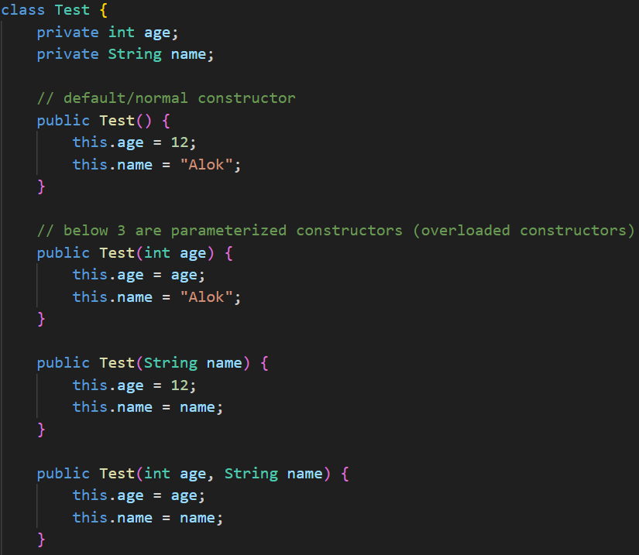
- Naming Conventions
  - Class, Interfaces : Pascal case (MyClass)
  - Variables, Methods : Camel case (myVar)
  - Constants : All capital (MY_CONST)
- Anonymous Object
  - It is just creating a object but not assigning it to any variable.
  - 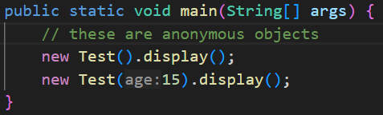
- Inheritance
  - Single Level Inheritance:
    - 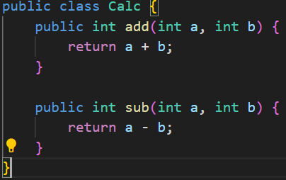
    - 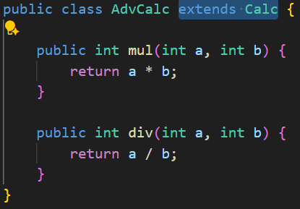
    - 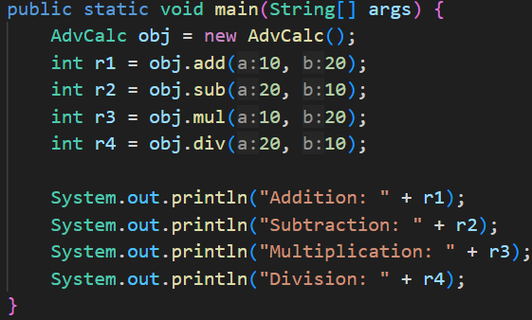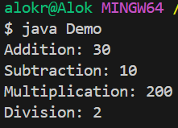
  - Multi Level Inheritance
    - 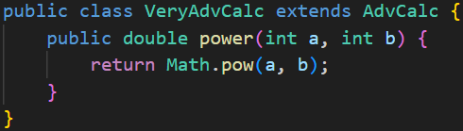
    - Now: VeryAdvCalc >> AdvCalc >> Calc
  - Multiple Inheritance
    - Java doesn’t support multiple inheritance.
- super method
  - super is nothing but the alias of parent class’s constructor.
    - When you write super(), it’ll call the parent class’s default (non-parameterized) constructor.
  - When a class inherits another class, even if you don’t write super() inside the constructor of the child class, java executes super() by default.
  - super.method_or_var_name (here non static methods/variables are only valid)
  - Super() (calls the parent class’s constructor)
  - 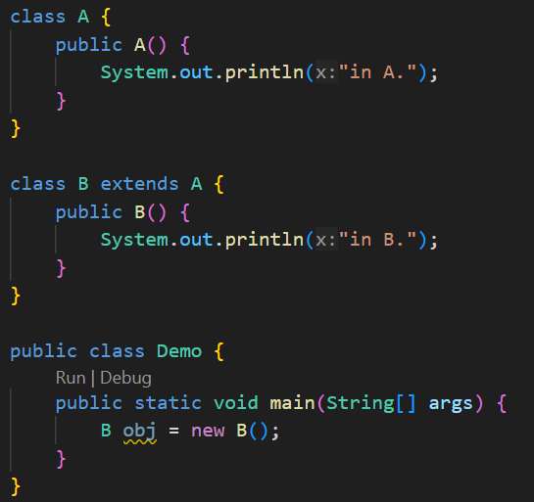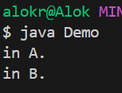
  - 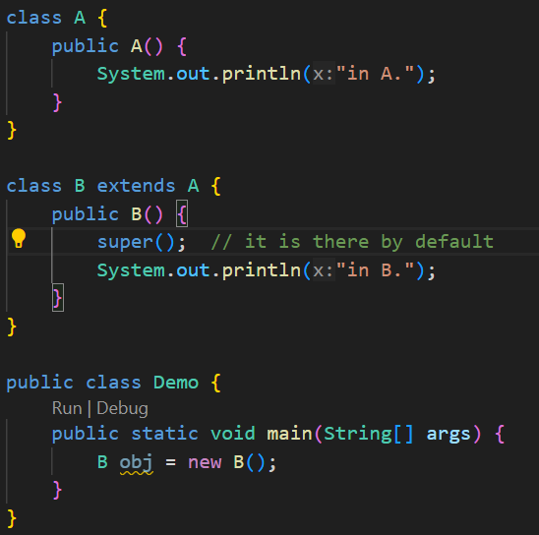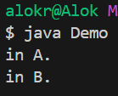
    - Both the above cases are same.
    - Even if you don’t call super() it’ll be called by default.
    - super() constructor call should be in the first line default/parameterized).
  - If there is only a parameterized constructor in the parent class, and if you don’t write super(arg), then it’ll give error.
    - Because, by default Java will call the parent’s constructor as super() only i.e. it’ll call only the default constructor (non-parameterized).
    - As there is only one constructor present in parent class, which is parameterized; calling super() in the child class will give error.
  - 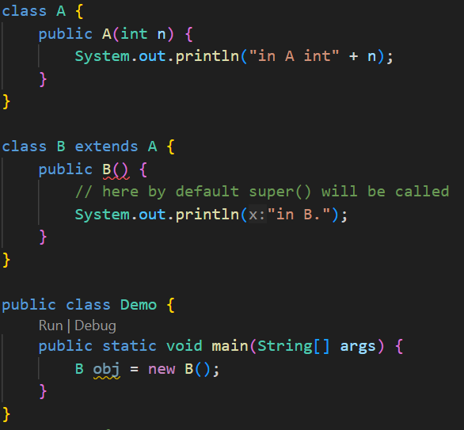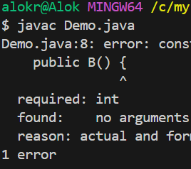
    - In this case, you need to call the parent’s parameterized constructor explicitly.
- this method
  - this refers to the current object instance; when you call this() it’ll call the current class’s constructor.
  - 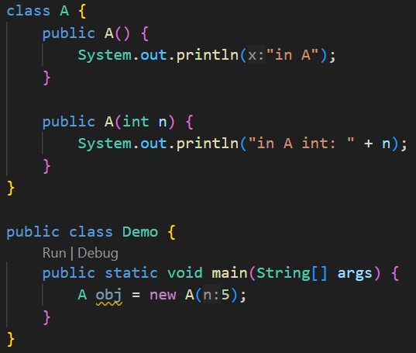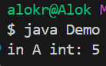
    - Here, by default the parameterized constructor got called as we passed one argument while instantiating the object.
    - If this is getting called inside the constructor, then it should be in the first line inside the constructor just like super.
    - this() and super() cannot be called inside the same constructor; because both of them needs to be written in the first line inside the constructor method.
  - 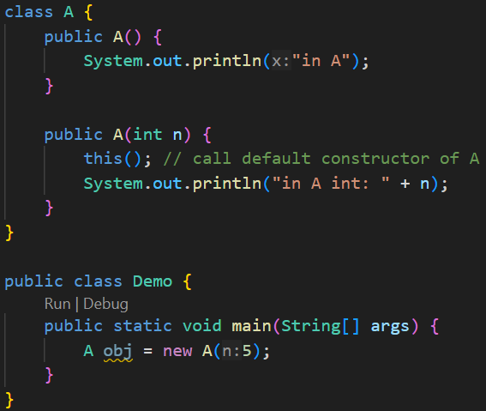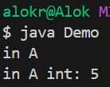
    - Now, as we called this() inside the parameterized constructor, so its calling the default constructor inside the class.
- Method Overriding
  - When child class implements same method which is present in the parent’s class as well; its called Method Overriding.
  - Same name, same type of arguments, same number of arguments, same return type; just different definition. (unlike method overloading: name/type/number of args/return type => one or more of these should be different)
  - 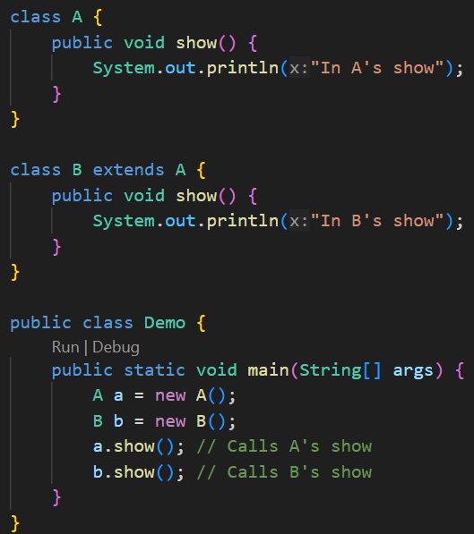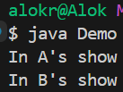
    - Its simple only; B’s show function is overriding A’s show function.
  - 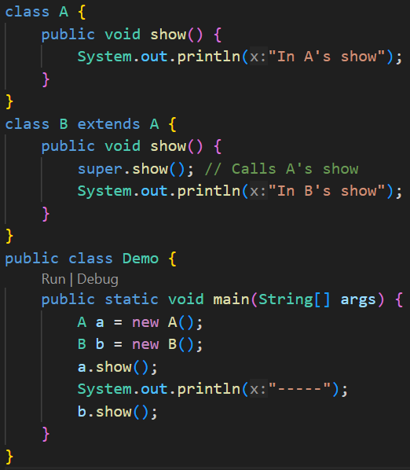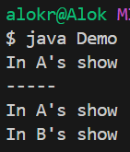
    - In here, I tried to implement some extra functionality inside the show() method. Not completely overriding A’s show method.
  - Whenever you call a method, it’ll search that method in the current class first; if it doesn’t get that then it’ll go to the parent class.
- Packages
  - Some related files should be separated and kept inside a folder. This folder will be treated as a package; but you need to mention the package name inside the files.
  - 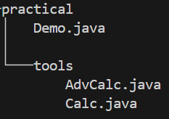
    - It is my current directory structure; I kept Calculator related stuffs inside the tools directory
  - 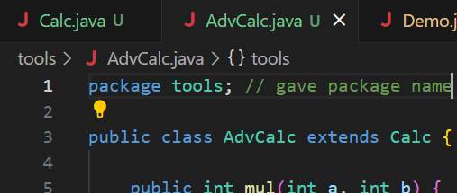
    - Gave the package name as tools in both Calc.java and AdvCalc.java
  - Now, we can’t use the classes (i.e. Calc and AdvCalc) inside the main method inside Demo class directly as both are now inside different folders.
    - 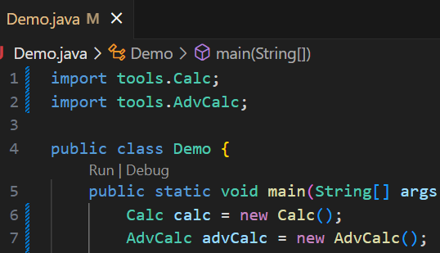
    - Instead of importing the modules one by one; we can import all the modules present inside that package directly using *
    - 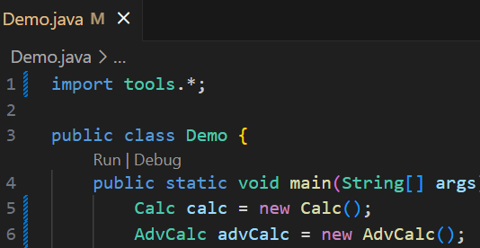
  - Now lets see nested package structure:
    - 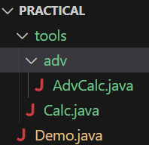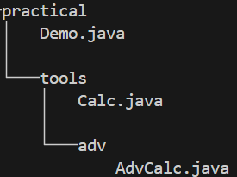
      - I transferred AdvCalc.java inside a new directory adv.
    - 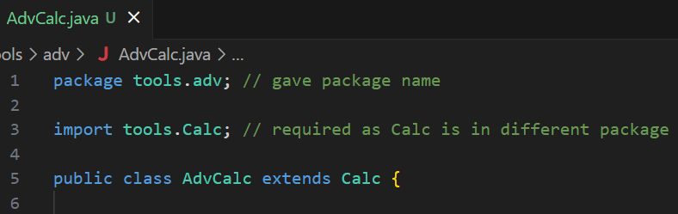
      - Now we need to import Calc as well as it is in different package now.
    - 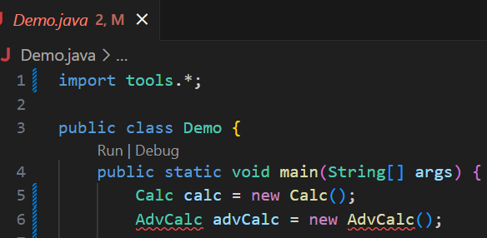
      - Here you can see, I have imported tools.* still getting error in AdvCalc.
      - It is because, packageName.* only imports the files present inside that package; in our case inside tools one more package is present which is adv.
      - So here, tools.* is only importing the Calc file. Its not importing tools/adv/AdvCalc file.
    - 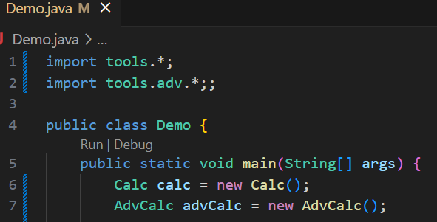
      - Now it’ll work properly.
  - You can’t give different package names to the files which are siblings to each other i.e. present inside the same folder.
- Access Modifiers
  - When you don’t give any access modifiers, it’ll be default which is package-private i.e. only the files present in same package can access those.
    - 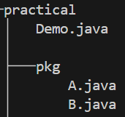 (This is my file structure for now)
    - 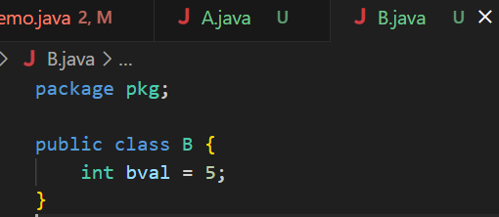
      - (practical/pkg/B.java)
    - 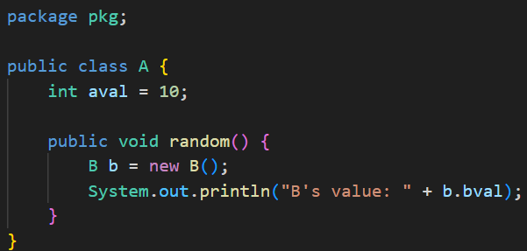
      - (practical/pkg/A.java)
      - You can see here, there is no error while accessing the variable of class B.
    - 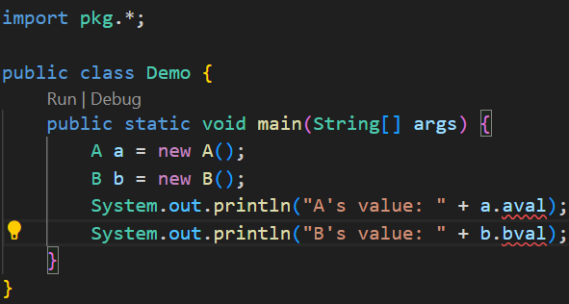
      - (practical/Demo.java)
      - Here, error is coming as Demo.java is not inside the package of A and B.
  - Public
    - It is accessible in everywhere; Within the class, Child class, Classes present inside same package, Classes present in different package etc etc.
  - Private
    - It is accessible only within the class. No where else it is accessible.
  - Protected (IMPORTANT)
    - Within the same package (just like default/package-private).
    - From subclasses in other packages (extra power over default).
    - 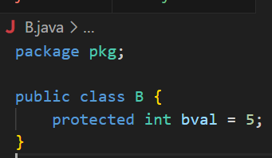
      - (practical/pkg/B.java)
    - 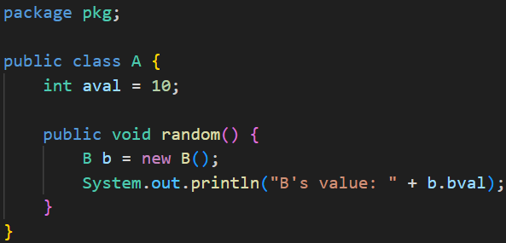
      - (practical/pkg/A.java)
      - No error because A and B are inside the same package.
    - 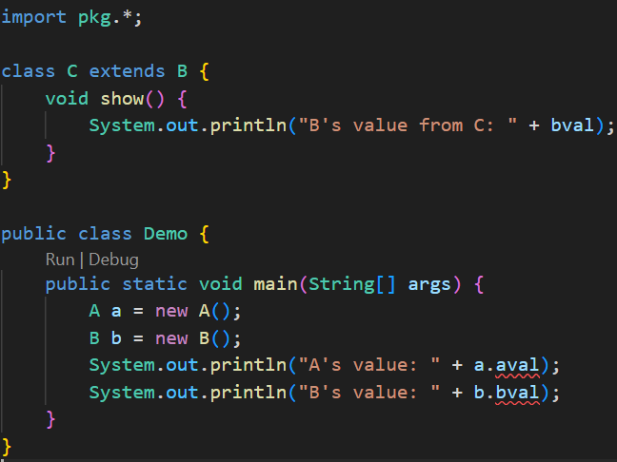
      - (practical/Demo.java)
      - Class C doesn’t give any error as it is inheriting Class B
      - But, inside Class Demo it is giving error because neither it is inheriting those classes not it is present inside the same package where A and B are present.
  - Protected and Package-Default varies in a single case which is:
    - In case of Protected, class X present outside of the package, if inheriting the class Y then it can access that protected variable of class Y.
    - In case of Package-Private, even if the class X is inheriting class Y but not present inside the package of Y, then it can’t access the variabled of Y.
  - We can’t have 2 public classes in a same file.
- Polymorphism
  - 2 types of polymorphism:
    - Compile time (Method Overloading)
    - Run time (Method Overriding)
- Dynamic Method Dispatch
  - Process by which a call to an overridden method is resolved at runtime rather than at compile-time.
  - Assigning a object of child class to a variable of type parent class (vice-versa is not true).
  - 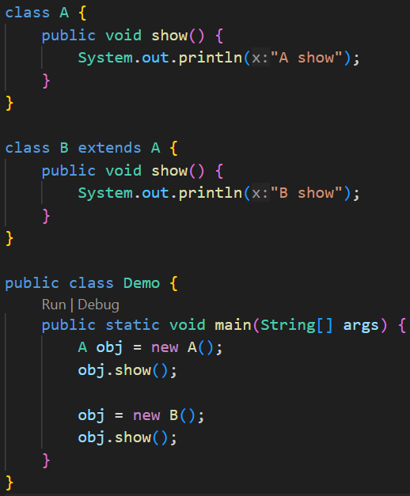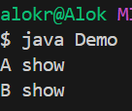
    - Here, the variable is of type A (parent class).
    - During the compile time, it is not sure that which show method will be called. It’ll be decided during the run time only.
      - The method, that will be called, depends upon the type of object, not type of variable. (it is only for overriding; for more check Upcasting and Downcasting)
- Final Keyword
  - Its used to create a constant variable.
  - Can be used to create variable, method, class
  - variable
    - 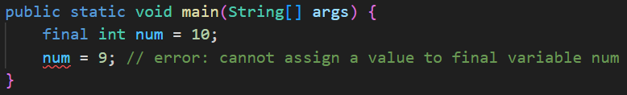
  - class
    - When you make your class final, means you are stopping further inheritance.
    - 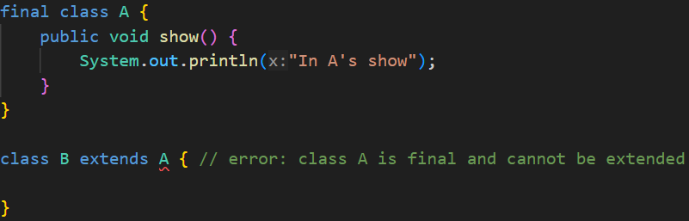
  - method
    - When you make the method final, means this method cannot be overridden.
    - 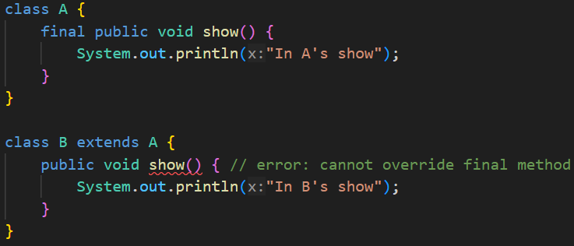
- By default, every classes inherits the class Object.
  - 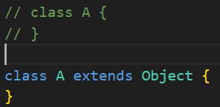
    - These both are same only.
- Some methods inside Object Class (toString, equals, hashcode)
  - 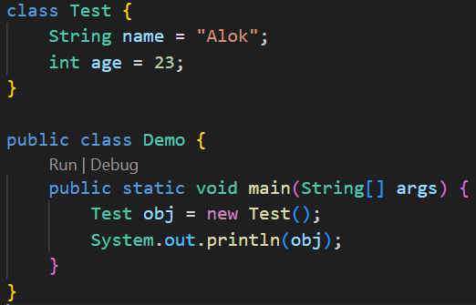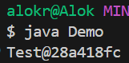
    - When I printed this object of class Test, it gave some output like this.
    - 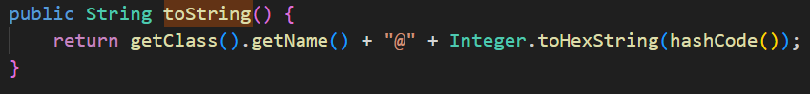
    - That output is because of this method present inside the class Object
    - We can modify that.
    - 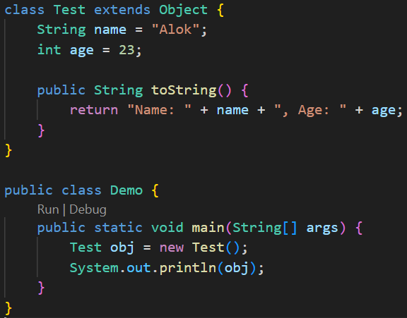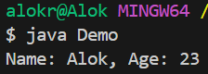
  - 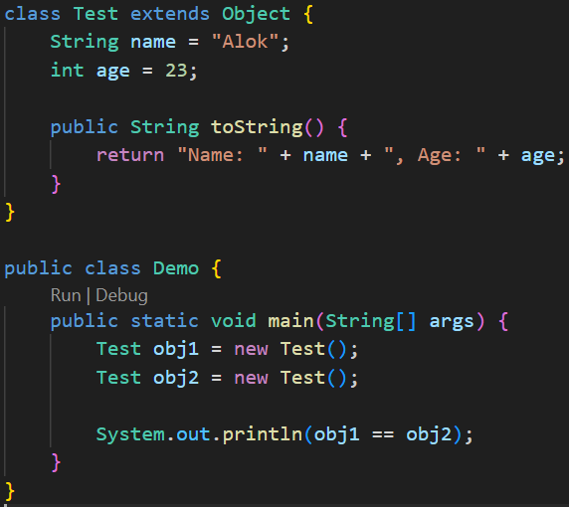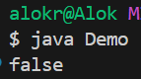
    - Now, it is giving false; it is because of the method equals present inside the class Object
    - 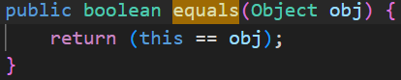
    - 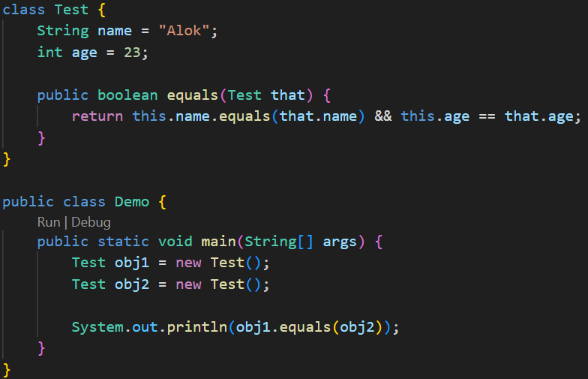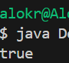

- Upcasting and Downcasting
  - 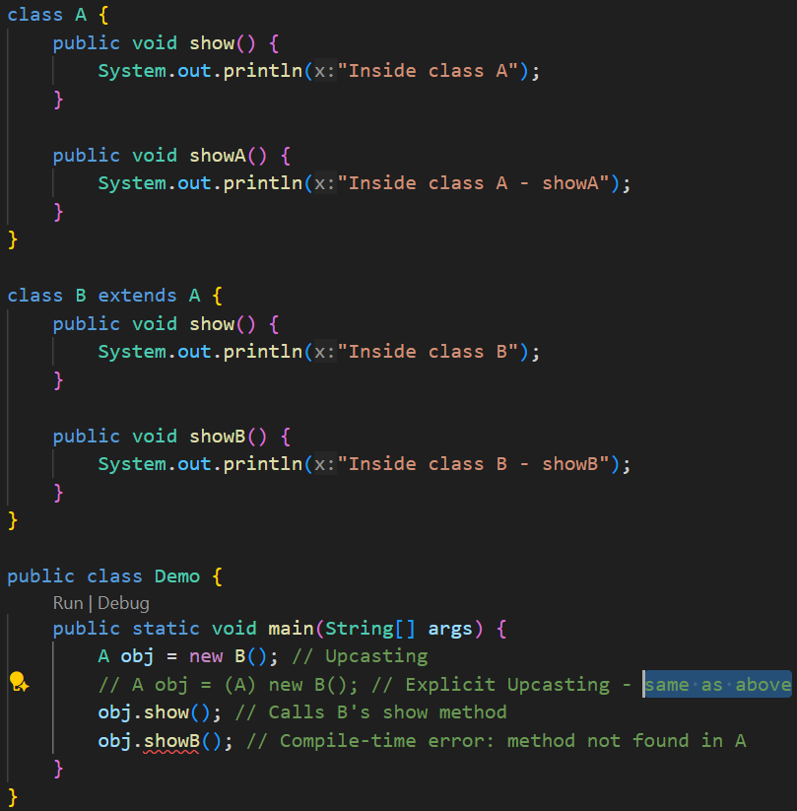
    - In here, even if the object is of type B, still you cannot call the method showB as the variable where it is getting stored is of type A.
    - In case of overriding, the method was present on A as well, so it just got overridden; but showB was not inside A; it is a completely new method for A; so it cannot be called.
    - It is Upcasting; assigning object of type Child to the variable of type Parent.
  - 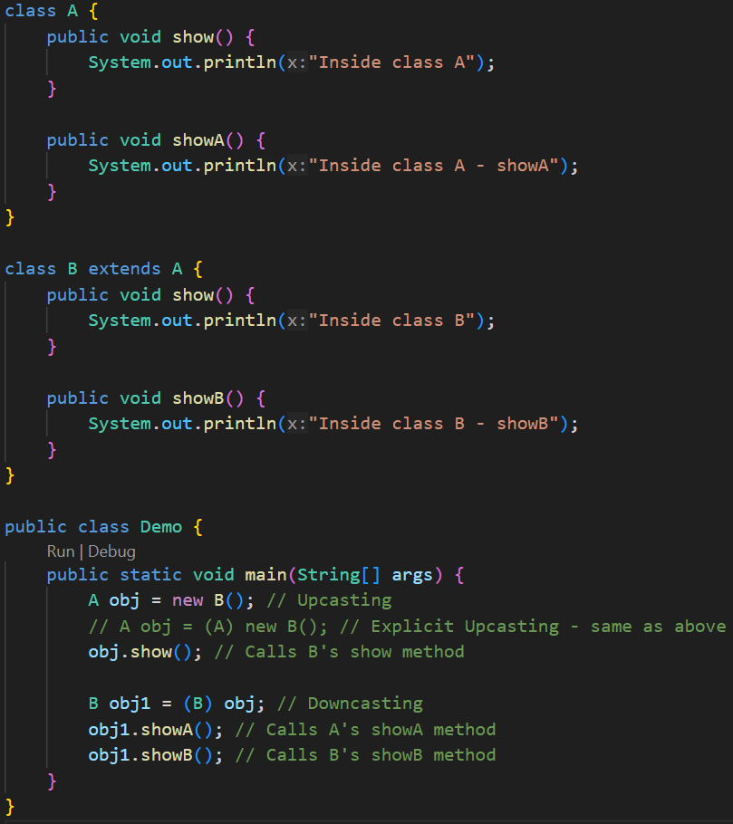
    - It’ll work fine.
    - We assigned the obj (which was of type A) to a variable of type B, but you need to explicitly Downcast this otherwise it’ll give error.
    - As B is the child class, so it can access both showA and showB.

- Wrapper Class
  - For all primitive type, there is a Object wrapper present in java.
  - For example: Integer, Double ..etc
  - 